Use Case Specification

DMT/RM01/TMP

|  |  |
| --- | --- |
| Project Code | PRJ_ Loan Application Processing System_001 |
| Project Name | Loan Application Processing System |

|  |  |  |
| --- | --- | --- |
| Prepared/Modified by | Role | Date of Preparation |
| Group 3 | Trainee Test Engineers | 26th May, 2018 |
| Reviewed by | Role | Date of Review |
|  |  |  |
| Approved by | Role | Date of Approval |
|  |  |  |
| Circulation List |  | Version Number of the template:1.1 |
| Version Number | 1.1 |  |

<<Customer>> REVIEW HISTORY

<<Customer comments on the Use case along with the signed off is tracked here>>

|  |  |  |  |  |  |  |  |
| --- | --- | --- | --- | --- | --- | --- | --- |
| Version | <<Version number>> |  |  |  |  |  |  |
| Date | <<Date of Review>> |  |  |  |  |  |  |
| Reviewed by | << Reviewer Name>> |  |  |  |  |  |  |
| Reviewed UI Specification doc | << Whether UI Specification doc is reviewed >> |  |  |  |  |  |  |
| All Open Queries/issues closed | << Whether all the open queries and issues resolved>> |  |  |  |  |  |  |
| Agreement on Assumptions | <<Whether all the assumptions have been agreed upon by the customer>> |  |  |  |  |  |  |
| Sign Off | <<Signature>> |  |  |  |  |  |  |

**Disclaimer**:The scope of the project ‘Loan Application Processing System’ is restricted to the contents of this signed off use case.

TABLE OF CONTENTS

1. Use Case Name: Applying for Loan and Checking the status of Application 5

2. Actor(s): 5

3. Preconditions 5

4. Flow of Events 5

4.1 Basic Flow 5

4.2 Alternative Flows 6

4.2.1 Alternate Flow 1 6

4.2.2 Alternate Flow 2 6

4.2.3 Alternate Flow 3 7

4.2.4 Alternate Flow 4 8

Exception Flow 1: Exceeded Login Attempts 8

Exception Flow 2: Web Server Down 8

Exception Flow 3: Database Connectivity Error 8

Exception Flow 4: Network Connectivity Error 8

5. Post Conditions 9

6. Special Requirements 10

Performance 10

Availability 10

User Interface 10

Security 10

7. Extension Points 11

Extension in Alternate Flow 1: 11

Extension in Alternate Flow 2: 11

8. Business Rules 11

9. Diagrams 11

Use Case Diagram for User 11

10. Scenarios 13

Success Scenarios 13

Failure Scenarios 13

11. Issues 13

12. UI Specifications 13

13. Inter System Dependencies 13

14. Integration with an already existing System of the <<Customer>><<Not Applicable>> 14

15. Assumptions 14

1. Use Case Name: Updating And Managing Loan Application Process System

Use Case ID: LAPS.Loan.Application_001

Brief Description:

This Use Case describes the process by which admin can login, update and manage the information in the Loan Application Processing system. For Login admin must be already registered on the System.

2. Actor(s):

1. Admin

3. Preconditions

1. Admin has already registered on the Loan Application Processing system portal.
2. Admin has entered the valid URL of Loan Application Processing system and is directed to the home page.
3. Admin has valid user id and the password

4. Flow of Events

4.1 Basic Flow

Name: Successful Login and Updating information

1. Admin clicks on the link of Loan Application processing system home page.
2. The system displays home page with options Administration login, lad login, Customer and check status.
3. Admin selects Administration login.
4. Admin enters Username.
5. Admin enters Password.
6. Admin clicks on the Login button.
7. The system validates Username & Password
8. The system navigates admin to the admin homepage and gives option to select from Add programs, View reports and Program details.
9. If Admin clicks on Add Programs then system navigates admin to the page displaying the programs to add.
10. If else Admin clicks on View report the system will navigate admin to the page displaying the list of loan Approved, Accepted and Rejected.
11. Else system navigates admin to Program details where admin can find the details of all the loans offered by the home finance provider.

4.2 Alternative Flows

4.2.1 Alternate Flow 1

1. Admin clicks on the bookmark of Loan Application processing system.
2. The system displays home page with options Administration login, lad login, Customer and check status.
3. Admin selects Administration login.
4. Admin enters Username.
5. Admin enters Password.
6. Admin clicks on the Login button.
7. The system validates Username & Password
8. The system navigates admin to the admin homepage and gives option to select from Add programs, View reports and Program details.
9. If Admin clicks on Add Programs then system navigates admin to the page displaying the programs to add.
10. If else Admin clicks on View report the system will navigate admin to the page displaying the list of loan Approved, Accepted and Rejected.
11. Else system navigates admin to Program details where admin can find the details of all the loans offered by the home finance provider.

4.2.2 Alternate Flow 2

1. Admin clicks on the App of Loan Application processing system.
2. The system displays home page with options Administration login, lad login, Customer and check status.
3. Admin selects Administration login.
4. Admin enters Username.
5. Admin enters Password.
6. Admin clicks on the Login button.
7. The system validates Username & Password
8. The system navigates admin to the admin homepage and gives option to select from Add programs, View reports and Program details.
9. If Admin clicks on Add Programs then system navigates admin to the page displaying the programs to add.
10. If else Admin clicks on View report the system will navigate admin to the page displaying the list of loan Approved, Accepted and Rejected.
11. Else system navigates admin to Program details where admin can find the details of all the loans offered by the home finance provider.

4.2.4 Alternate Flow 3

Exception Flow 1: Adding Loan Not Offered By Home Finance Minister

1. Admin clicks on the link of Loan Application processing system home page.
2. The system displays home page with options Administration login, lad login, Customer and check status.
3. Admin selects Administration login.
4. Admin enters Username.
5. Admin enters Password.
6. Admin clicks on the Login button.
7. The system validates Username & Password
8. The system navigates admin to the admin homepage and gives option to select from Add programs, View reports and Program details.
9. Admin clicks on Add Programs then system navigates admin to the page displaying the programs to add.
10. Admin add new loans and clicks on submit.

Exception Flow 2: Adding Already Existing Loan

1. Admin clicks on the link of Loan Application processing system home page.
2. The system displays home page with options Administration login, lad login, Customer and check status.
3. Admin selects Administration login.
4. Admin enters Username.
5. Admin enters Password.
6. Admin clicks on the Login button.
7. The system validates Username & Password
8. The system navigates admin to the admin homepage and gives option to select from Add programs, View reports and Program details.
9. Admin clicks on Add Programs then system navigates admin to the page displaying the programs to add.
10. Admin add new loans and clicks on submit.
11. System displays error message as the load added already exists.

Exception Flow 3: Invalid Login

1. Admin clicks on the link of Loan Application processing system home page.
2. The system displays home page with options Administration login, lad login, Customer and check status.
3. Admin selects Administration login.
4. Admin enters Username.
5. Admin enters Password.
6. Admin clicks on the Login button.
7. The system validation fails.
8. The system shows error message regarding invalid credentials.

Exception Flow 4: Web Server Down

1. Admin clicks on the link of Loan Application processing system home page.
2. The system displays an error message regarding web server unavailability problem

Exception Flow 5: Database Connectivity Error

1. Admin clicks on the link of Loan Application processing system home page.
2. The system displays home page with options Administration login, lad login, Customer and check status.
3. Admin selects Administration login.
4. Admin enters Username.
5. Admin enters Password.
6. Admin clicks on the Login button.
7. The system validates Username & Password
8. The system navigates admin to the update and manage page of Loan Application processing system portal.
9. The system displays an error message regarding database connectivity problem

Exception Flow 6: Network Connectivity Error

1. Admin clicks on the link of Loan Application processing system home page.
2. The system displays home page with options Administration login, lad login, Customer and check status.
3. Admin selects Administration login.
4. Admin enters Username.
5. Admin enters Password.
6. Admin clicks on the Login button.
7. The system validates Username & Password
8. The system navigates admin to the update and manage page of Loan Application processing system portal.
9. Admin chooses to add information to the portal by Home finance provider.
10. The system displays an error message regarding network connectivity problem

5. Post Conditions

| Flow Name | Post Condition |
| --- | --- |
| Invalid Login | Displays error message regarding the invalid credentials. |
| Adding loan not offered by Home finance provider | The system will display an error message to the admin regarding the new added loan is not offered by Home finance provider |
| Adding already existing Loan | The system will display an error message to the admin regarding the loan added already exist in the homepage. |
| Web Server Down | The system should display an error message to the user regarding web server unavailability problem |
| Database Connectivity Error | The system should display an error message to the user regarding the database connectivity problem |
| Network Connectivity Error | The system should display an error message to the user regarding the network connectivity problem |

6.Special Requirements

Performance

1. The click on ‘View reports’ shall display the list of loans approved, rejected and approved within 15 seconds of admin request.

Availability

1. The admin can update Loan only on working days and working hours.

2. Application is up and running 24*7.

User Interface

* 1. The letters on Menus shall be bold
  2. The active links shoul be displayed in red color
  3. The visisted links should be displayed in purpule color
  4. The Unvisited links should be displayed in blue
  5. The logout and back button should be available on every page of the application
  6. Look and feel and color of application should be proper
  7. In case of Field level validation error messages should be displayed in red color

Security

1. The system shall display the letters of PIN numbers in a masked format when they are entered by the admin.
2. After clicking on back on browser it should takes you back to the previous page in the list
3. After clicking on Forword on browser it should takes you forward to the next page in the list.
4. Admin session should get expire if it is inactive for 10 mins.

7. Extension Points

Extension in Alternate Flow 1:

In step 4, if the admin has entered wrong user credentials:

1. The system prompts the admin to re-enter the credentials.

2 Admin enters the username and password.

3. The system takes admin to the Step 6 of Basic Flow.

8. Business Rule

| Business Rule Name | Business Rule Description | System action (if BR fails) |
| --- | --- | --- |
| BR01 | Admin must be valid | Admin is prompted to re-enter the login credentials |
| BR02 | Admin cannot delete the loan for which customers have already applied for | Admin is prompted to select valid details for deleting. |

9.Diagram

Use Case Diagram for Admin

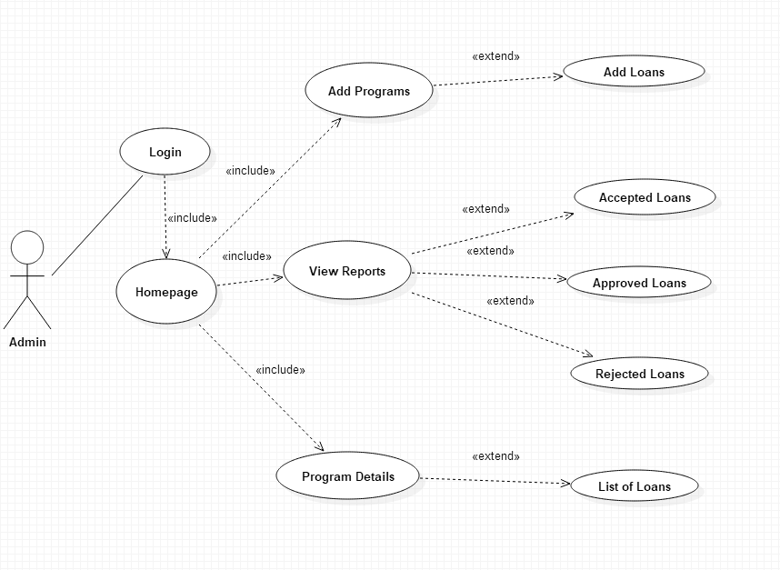

Activity Diagram

10. Scenarios

Success Scenarios

1. Successful addition of information of the loan programs offer by the home finance provider.

Failure Scenarios

1. Web Server Down

2. Database Connectivity Error

3. Network Connectivity Error

11. Issues

1. What is the maximum numbers of loans added or deleted at a time?

12. UI Specifications

https://www.onlineloanapplication.com

14. Inter System Dependencies

Module: ‘Loan application processing system’ gets impacted due to:

Use case name: Loan Application Process

Flow name : Alternate Flow 1

Impact: If the admin tries to change anything without login, he/she should be denied so**.**

15. Integration with an already existing System of the <<Customer>><<Not Applicable>>

16. Assumptions

1. Admin should know the valid URL of Loan Application Processing System.
2. Admin should have Google chrome browser for best view of site..

REVISION HISTORY OF THE WORK PRODUCT

<to be maintained by projects>

|  |  |  |  |  |  |
| --- | --- | --- | --- | --- | --- |
| # | Date | Version # | Section Changed | Details of changes made | Approved By |
| 1 |  |  |  |  |  |
| 2 |  |  |  |  |  |